Question acids and Bases

1.

Three medicine tablets, which were claimed by the pharmaceutical company to each, contain 300mg of aspirin C₆H₄(OCOCH₃)COOH, were heated in 50.00ml of a 0.5090 M NaOH. The aspirin reacted as per the following equation:

C₆H₄(OCOCH₃)COOH + 2NaOH (aq) → C₆H₄(OCOCH₃)COONa (aq) + CH₃COONa (aq) + H₂O (l)

After cooling, the solution was transferred to a 100ml standard flask and the volume was made up to exactly the 100.0ml mark. Aliquots of 20.0 ml of this solution were then tirated against 0.1232 M HCl. The mean titre was 25.10 ml.
- What was the average mass of aspirin in the tablets?
- From your answer to a) comment on the pharmaceutical company’s claim.
2.

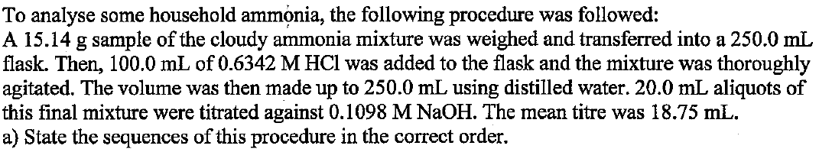
b) Write the equations for each the reaction steps

c) Calculate the % of ammonia in the original commercial cloudy ammonia

d) If the student’s final calculate % was less than the claimed by the company, does it conclusively mean that the company made a false statement?

3.

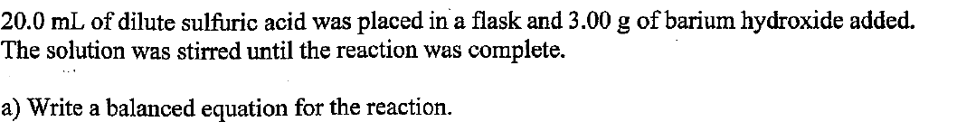

c) What indicator would be suitable for this reaction?

d) Calculate the original concentration of the sulfuric acid solution?

4.

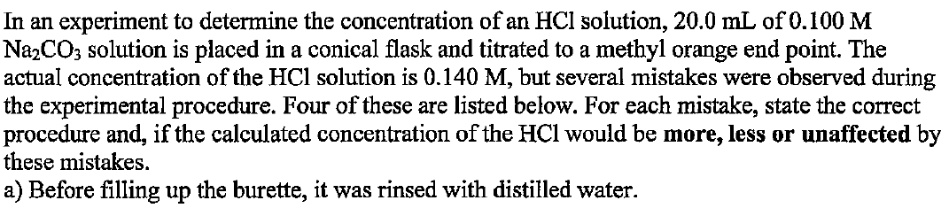
b) The conical flask is rinse with distilled water before adding the Na₂CO₃ solution
c) The pipette used to deliver the Na₂CO₃ is rinsed with water
d) Phenolphthalein is used as the indicator, instead of methyl orange

